**Photography Tips For Beginners**

There’s plenty of tips and tricks in photography that can help elevate your skills and take to you the next level as a photographer. From sticking to the golden hour for portraits to understanding the rule of thirds, check out our favorite photography tips for beginners below:

Basic Photography Tips



1. Get in close. Zoom decreases your photo quality, but your feet don’t. As long as it’s safe, physically move closer to your subject for a better photo.
2. Practice every day. Practice makes perfect and photography is no exception. Get out there and start taking photos.
3. Check for even lighting. Harsh shadows or lack of light will severely impact the look of your photo. Get an external light source or schedule your photoshoot for the right time.
4. Keep an eye out for composition. Photo composition, or the arrangement of visual elements, is key to telling your whole story.
5. Keep your batteries charged. Nothing puts a stop to a photoshoot faster than dead batteries.
6. Plan out your depth of field. How far away is your subject? Is you subject clear and in focus? These questions all have to deal with your depth of focus.
7. Watch for the golden hour. The Golden hour is the time when natural light is diffused and even. This time occurs in the two hours after sunrise or two hours before sunset.
8. Stick to the rule of thirds. The rule of thirds will help you compose your photo so that nothing is dead center or framed in a visually boring way. Keep your subject or composition filling two of three grid lines for this trick.
9. Experiment with filters. Filters can help you take your photo and make it something special. Check out our resource on the [best photo filter apps](https://www.shutterfly.com/ideas/photo-filter-apps/) for more information.
10. Learn how to work with motion. Read our guide on [how to take action photos](https://www.shutterfly.com/ideas/sport-photos/) for help with this.
11. Edit your photos. After your photoshoot make sure to take the time to edit your favorite photos. Often this will be the step that makes them outstanding finished projects. Look to our guide on [best photo editing apps](https://www.shutterfly.com/ideas/photo-editing-apps/) for help.
12. Keep your photos organized. Our [digital scrapbooking tips](https://www.shutterfly.com/ideas/digital-scrapbooking-tips/) will help make sure nothing is ever lost.

Nature Photography Tips

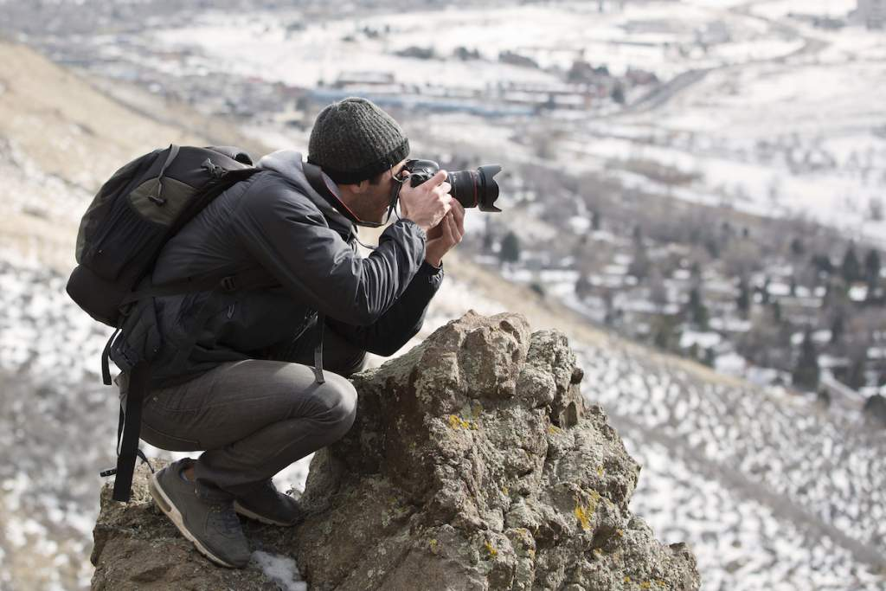

1. Focus on perspective. Sometimes a new angle is all you need to make your photograph instantly better.
2. Try micro or macro photography. Appreciate the*little* things in life, and photography. Don’t be afraid to get up close and personal.
3. Don’t overpack equipment. Nothing weighs you down in your efforts like weight. Seriously ask yourself before setting out if you need that third lens or heavyweight tripod.
4. Plan ahead. Read more about this and other [travel photography tips](https://www.shutterfly.com/ideas/travel-photography-tips/) from our hub.

Portrait Photography Tips



1. Be aware of your background. Nothing ruins a planned portrait photoshoot quicker than someone putting up bunny ears in the background.
2. Check your exposure. You never want your subject to be either under or over exposed in the photo– or you’ll risk losing key features. Check this ahead of time.
3. Make sure your subject is relaxed. If you subject is nervous or upset, it’ll show through in the photograph. Try having a normal conversation with them or distracting them between photos to help put them at ease.
4. Try to include some variation. Whether this means changing up the scenery, their outfit, both, or something else entirely – variation is interesting. And interesting photos will always top plain photos.
5. For family portraits, stay organized. There’s a lot that ties together when going for a [family photo](https://shutterflywpe.wpengine.com/family-photo/) session. Keep everyone on track so you get the best photo outcome.